READ MEASURING TOOLS
KS1 – 2002 Paper
1.
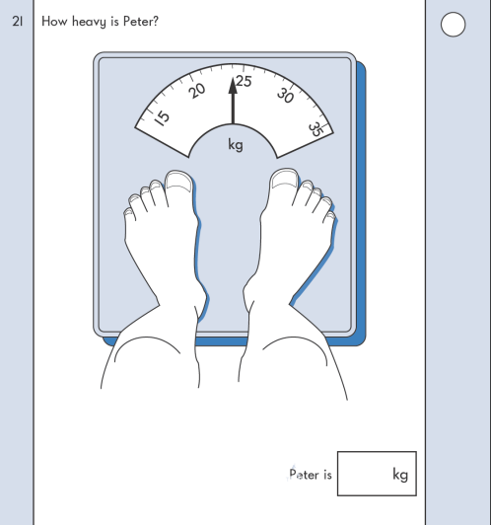
KS1 – 2005 Paper 2
2.
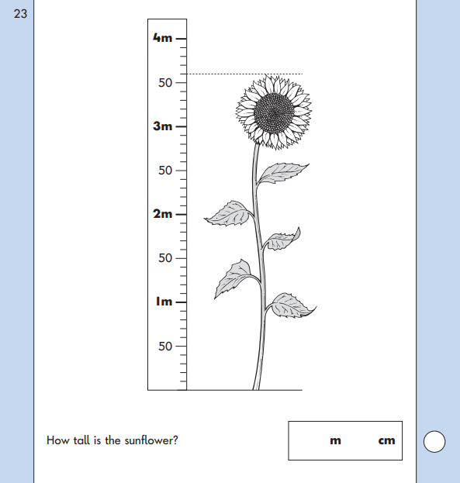
KS1 – 2007 Paper 1
3.

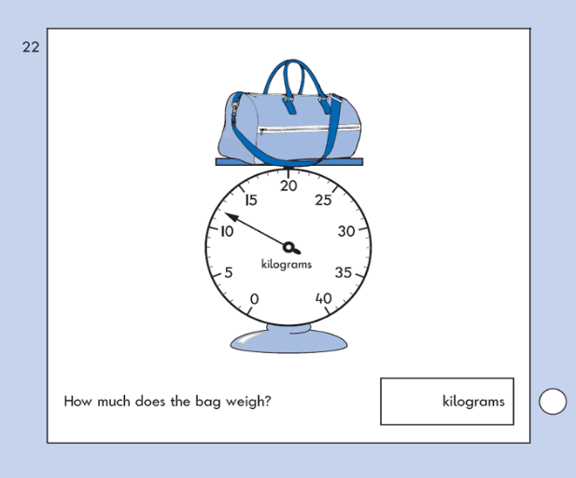
KS1 – 2009 Paper 2
4.

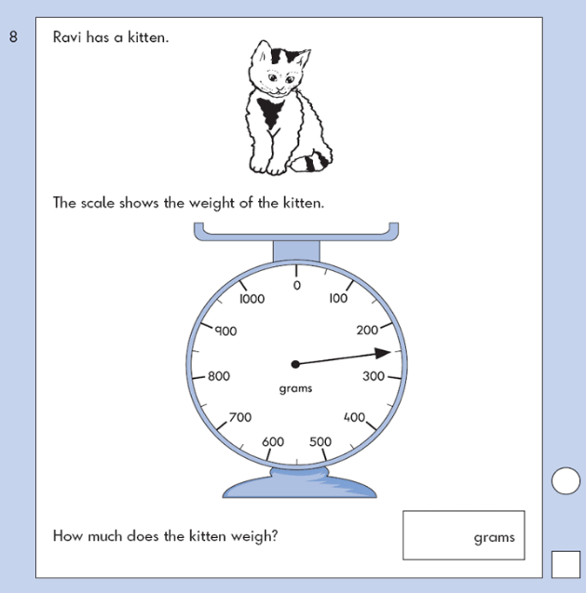
KS1 – 2016 Paper – Reasoning (Second)
5.
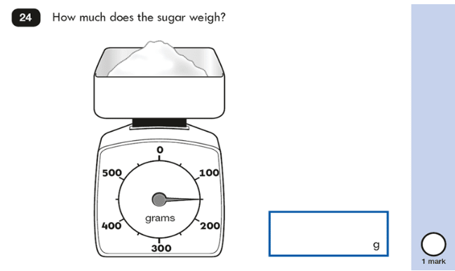
KS1 – 2018 Paper – Reasoning
6.

